**Assignment 1**

**Date : 01.03.2022**

**Submission date: 03.03.2022**

Write Algorithm & Flowchart for following programs.

1. Check the given number is EVEN or ODD.

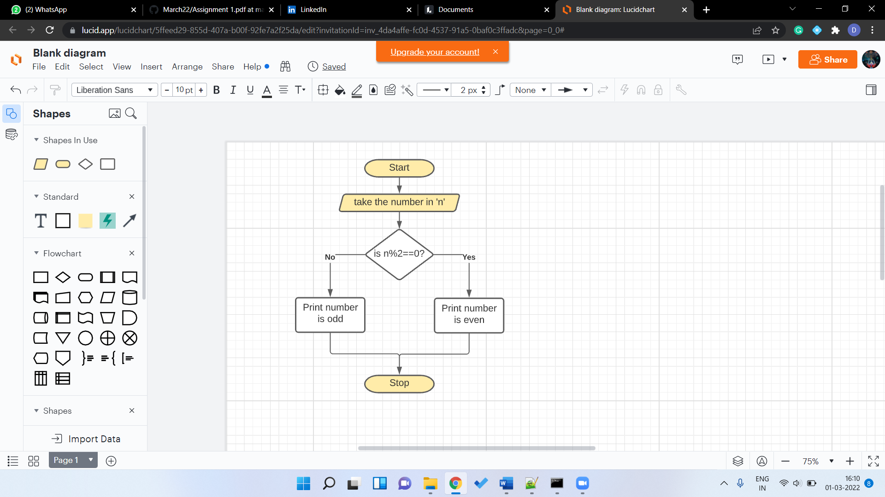

2. Write a Java Program to find the Factorial of given number.

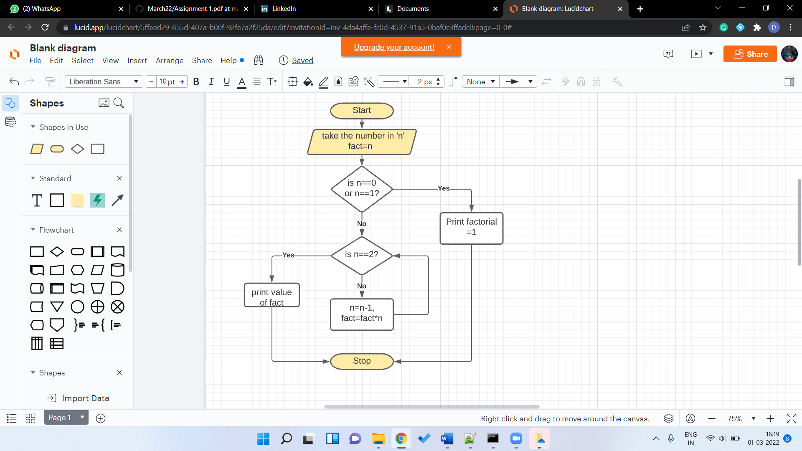

3. Find the Factorial of a number using Recursion.

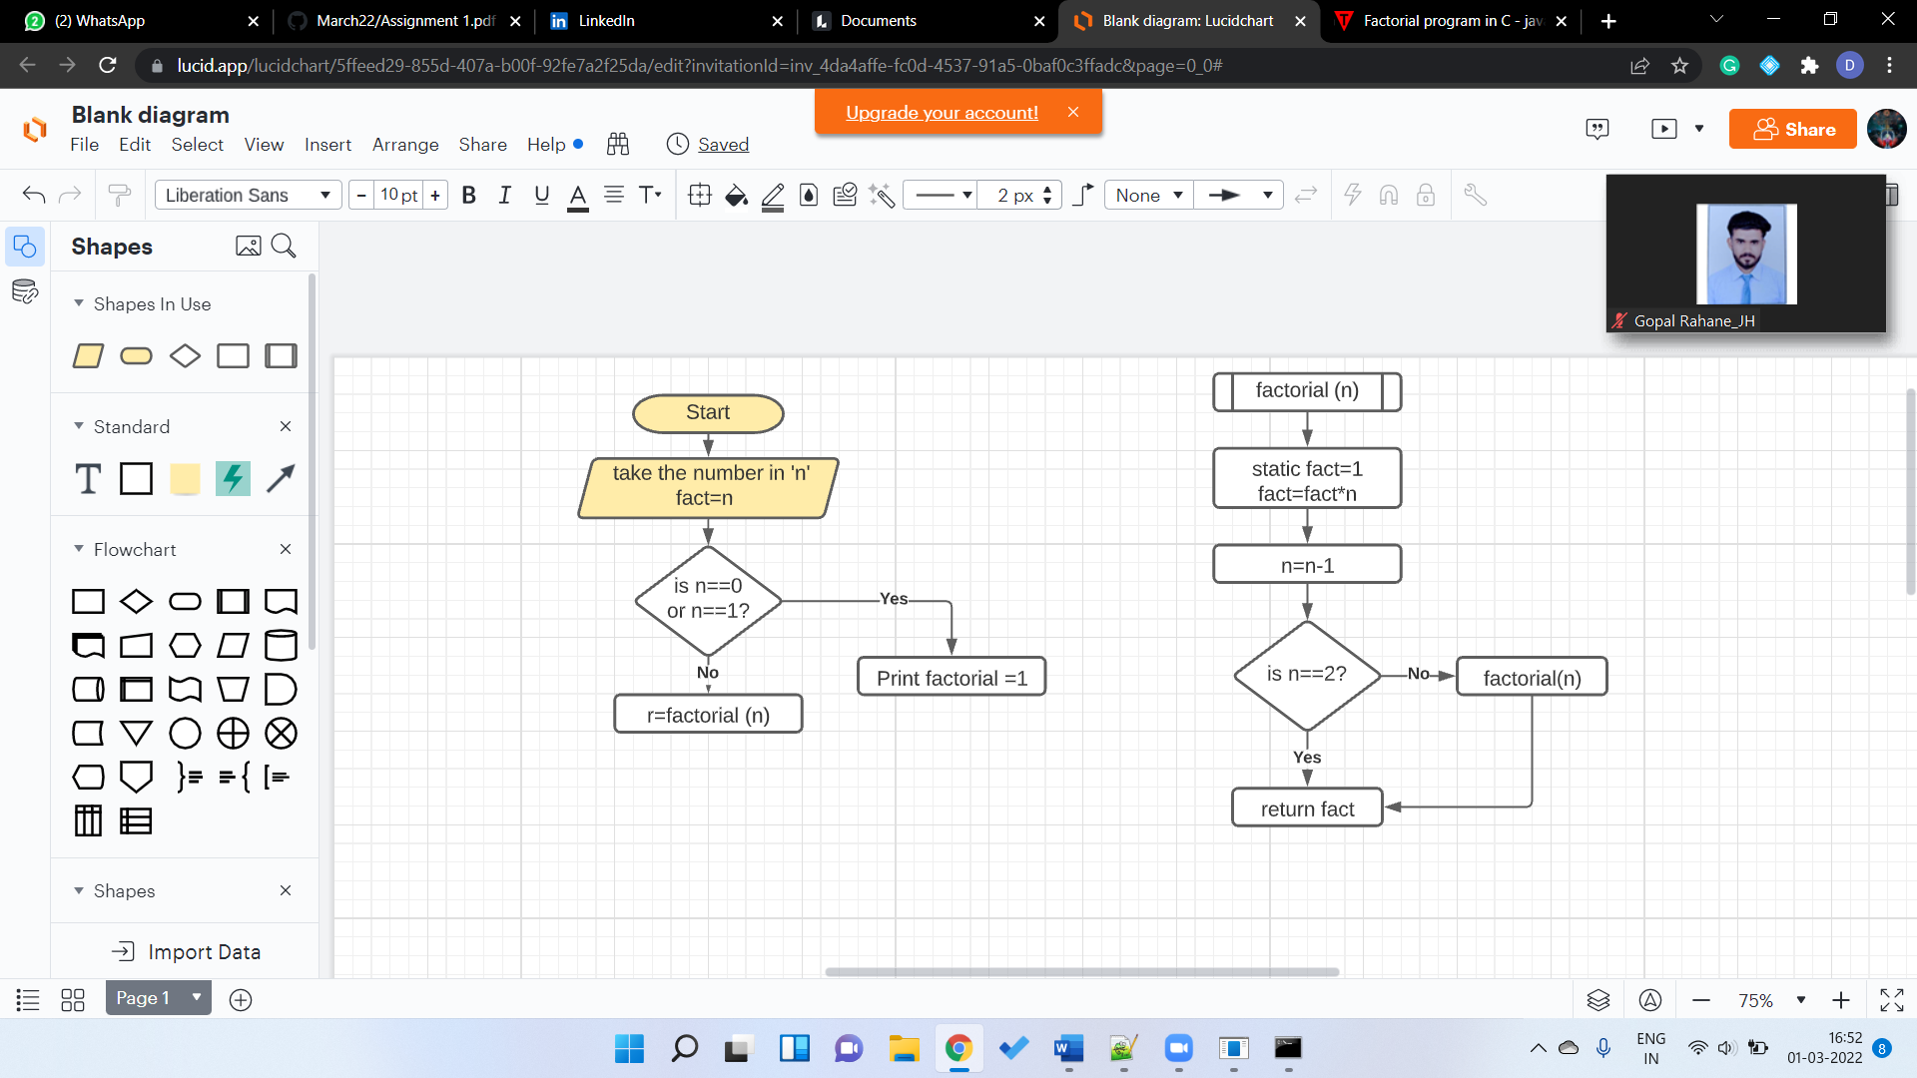

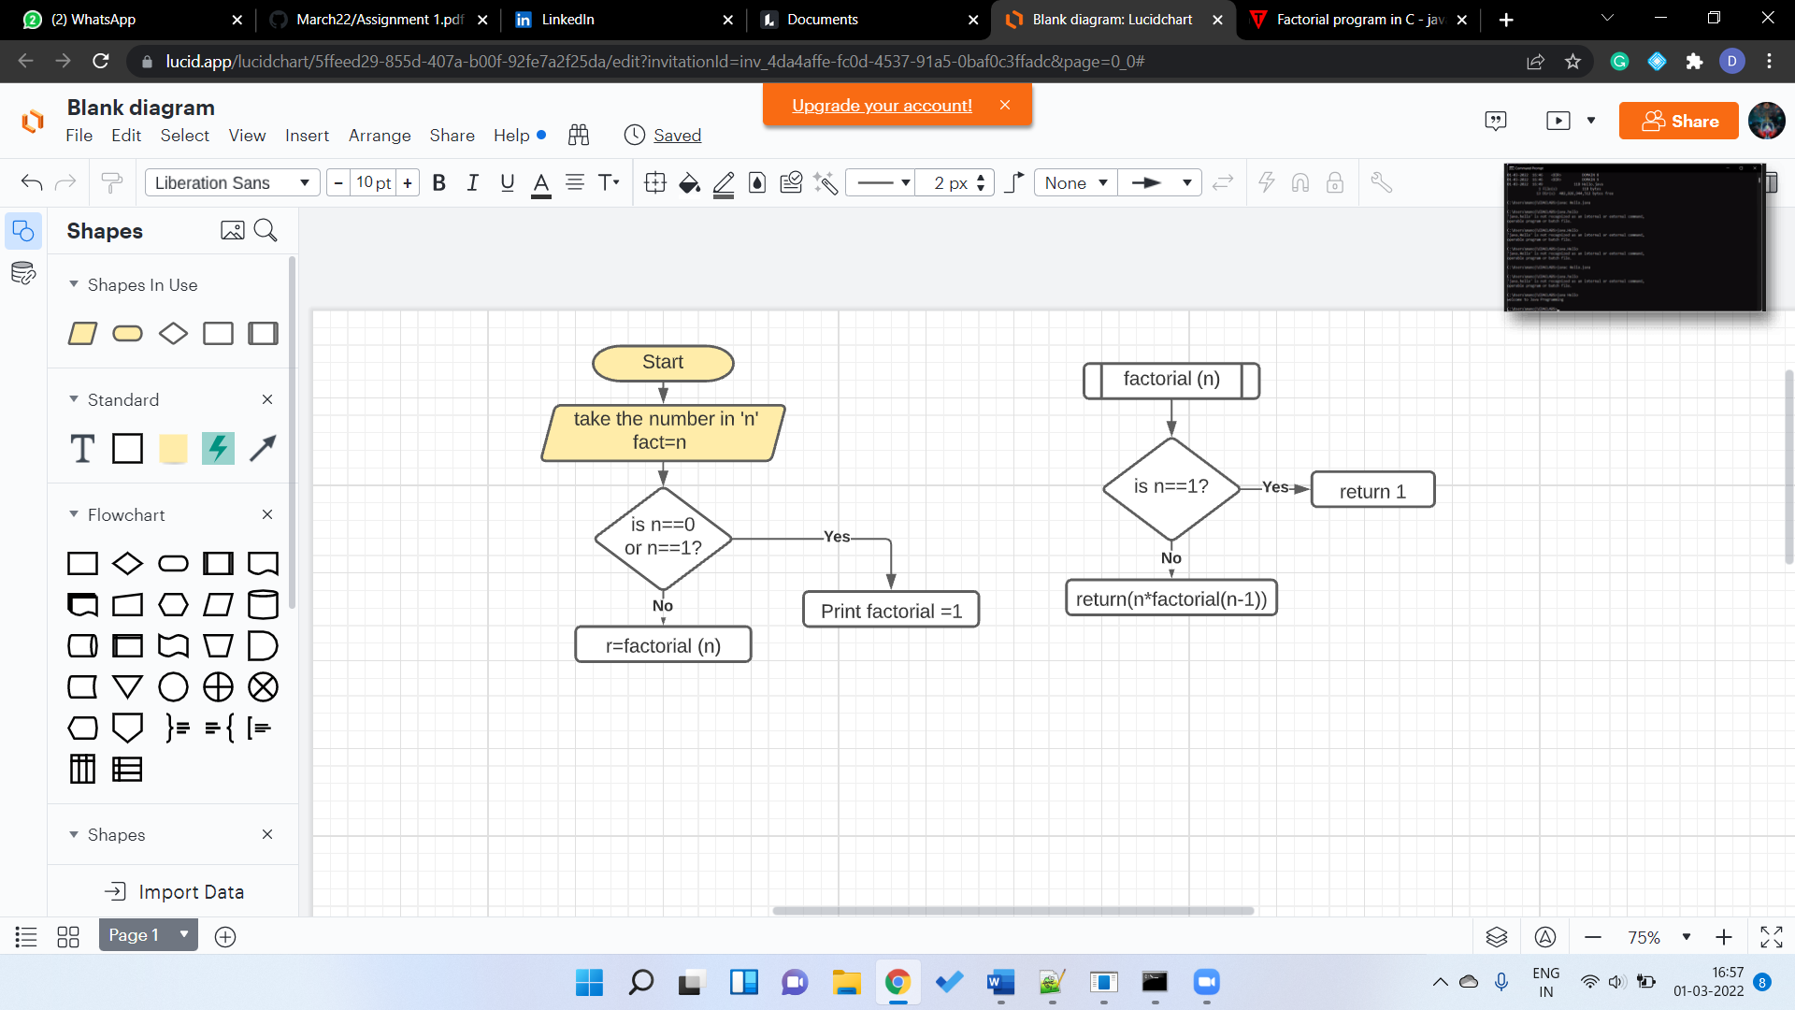

4. Swap two numbers without using third variable approach.

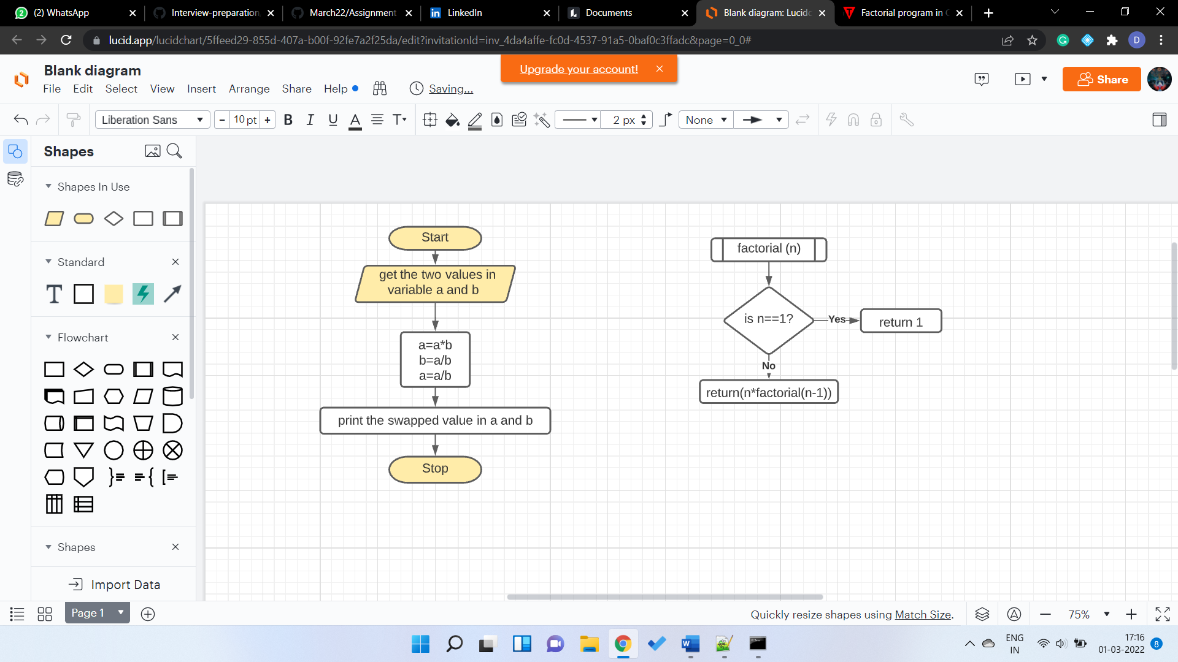

5. How to check the given number is Positive or Negative in Java?

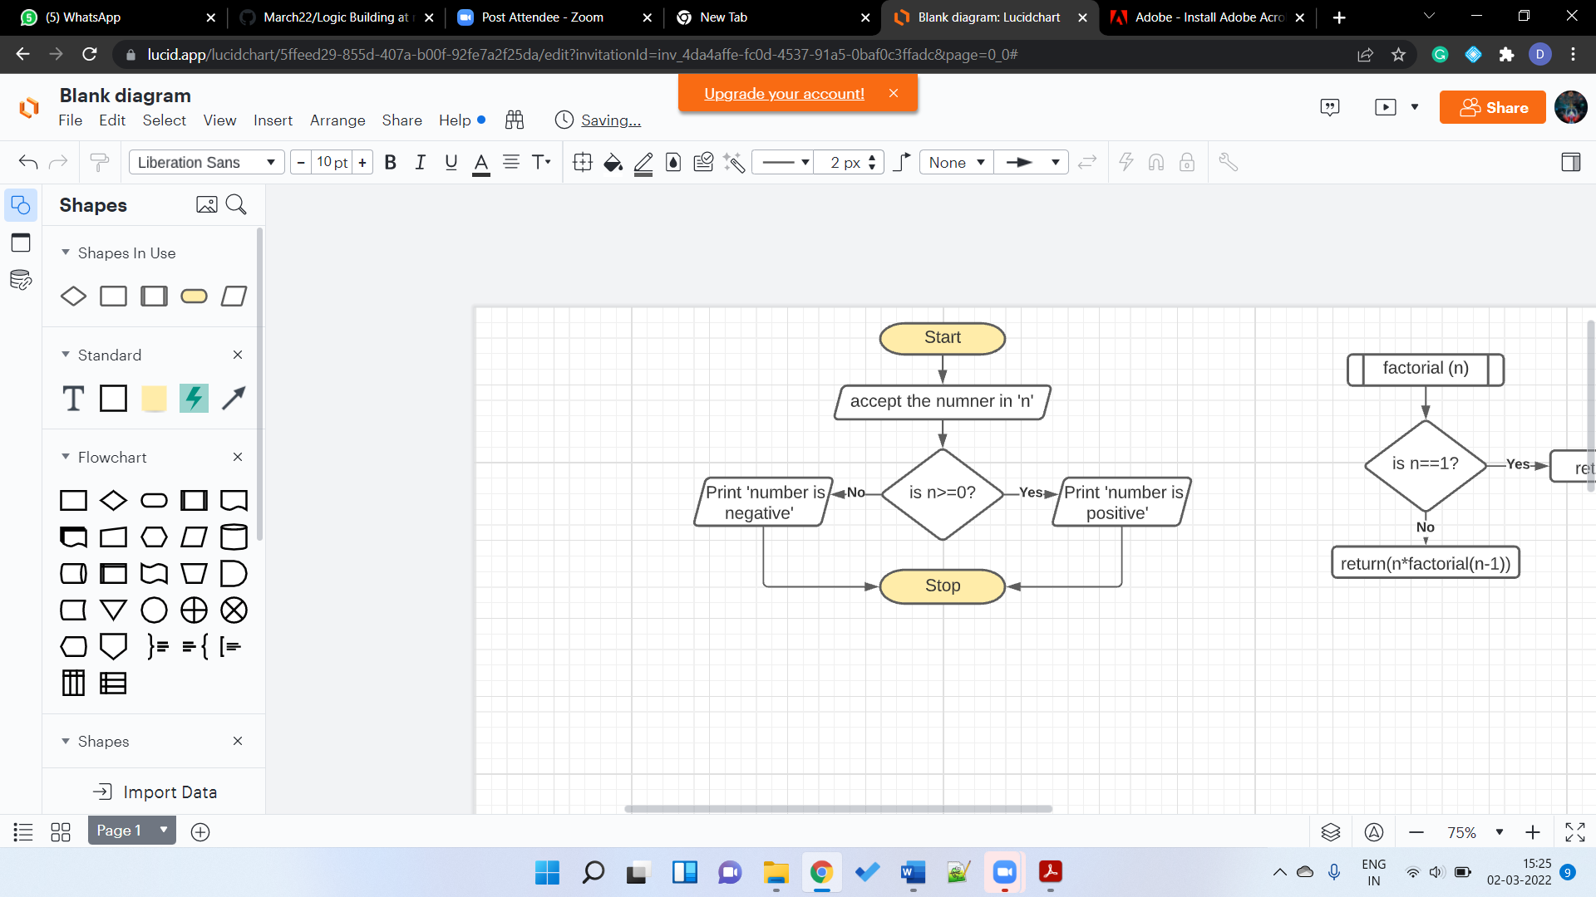

6. Write a Java Program to find whether given number is Leap year or NOT?

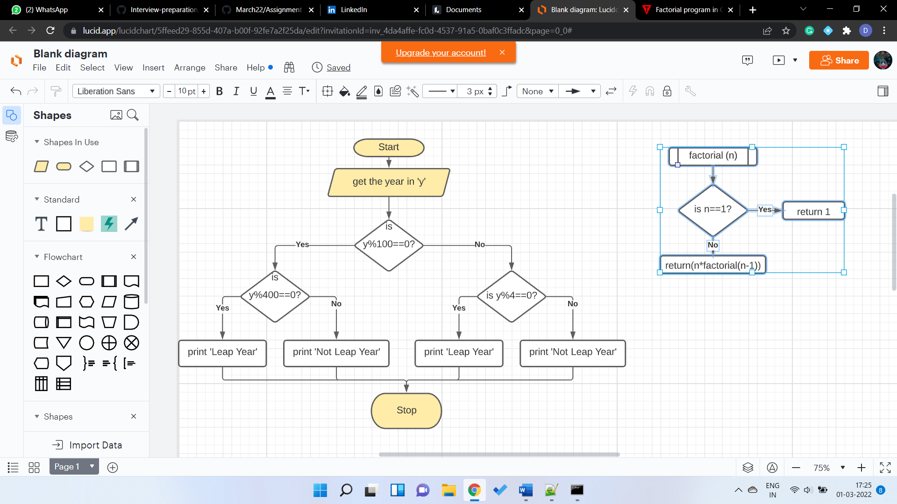

7. Write a Java Program to Print 1 To 10 Without Using Loop.

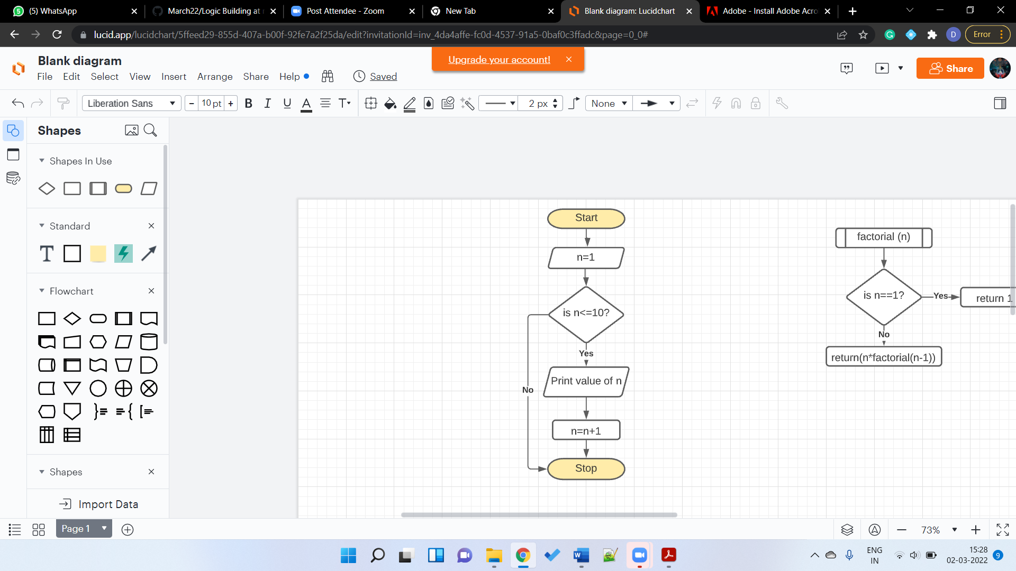

8. Write a Java Program to print the digits of a Given Number.

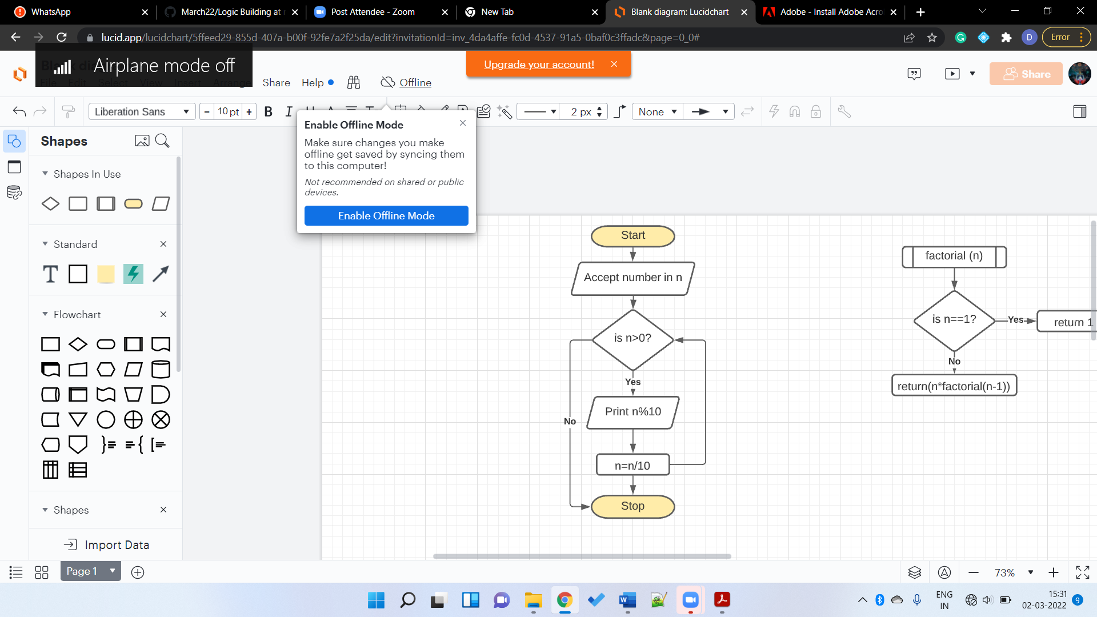

9. Write a Java Program to print all the Factors of the Given number.

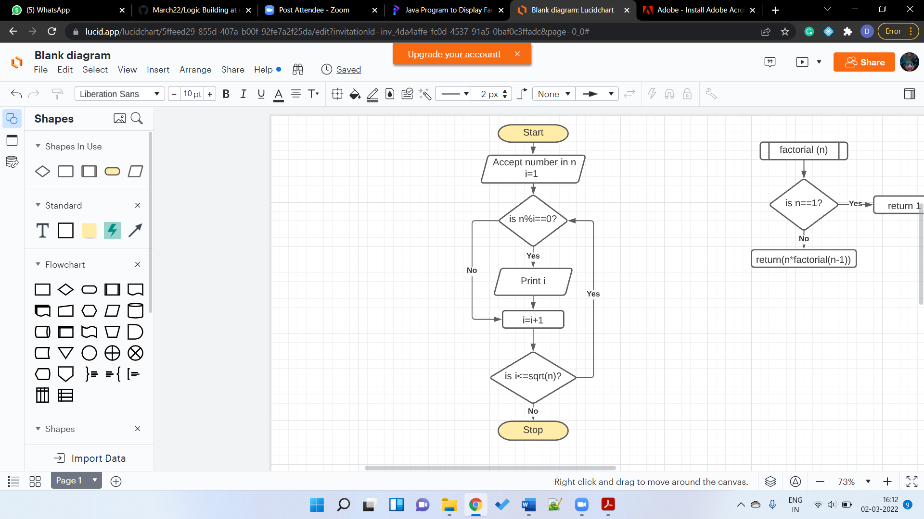

10. Write a Java Program to find sum of the digits of a given number.

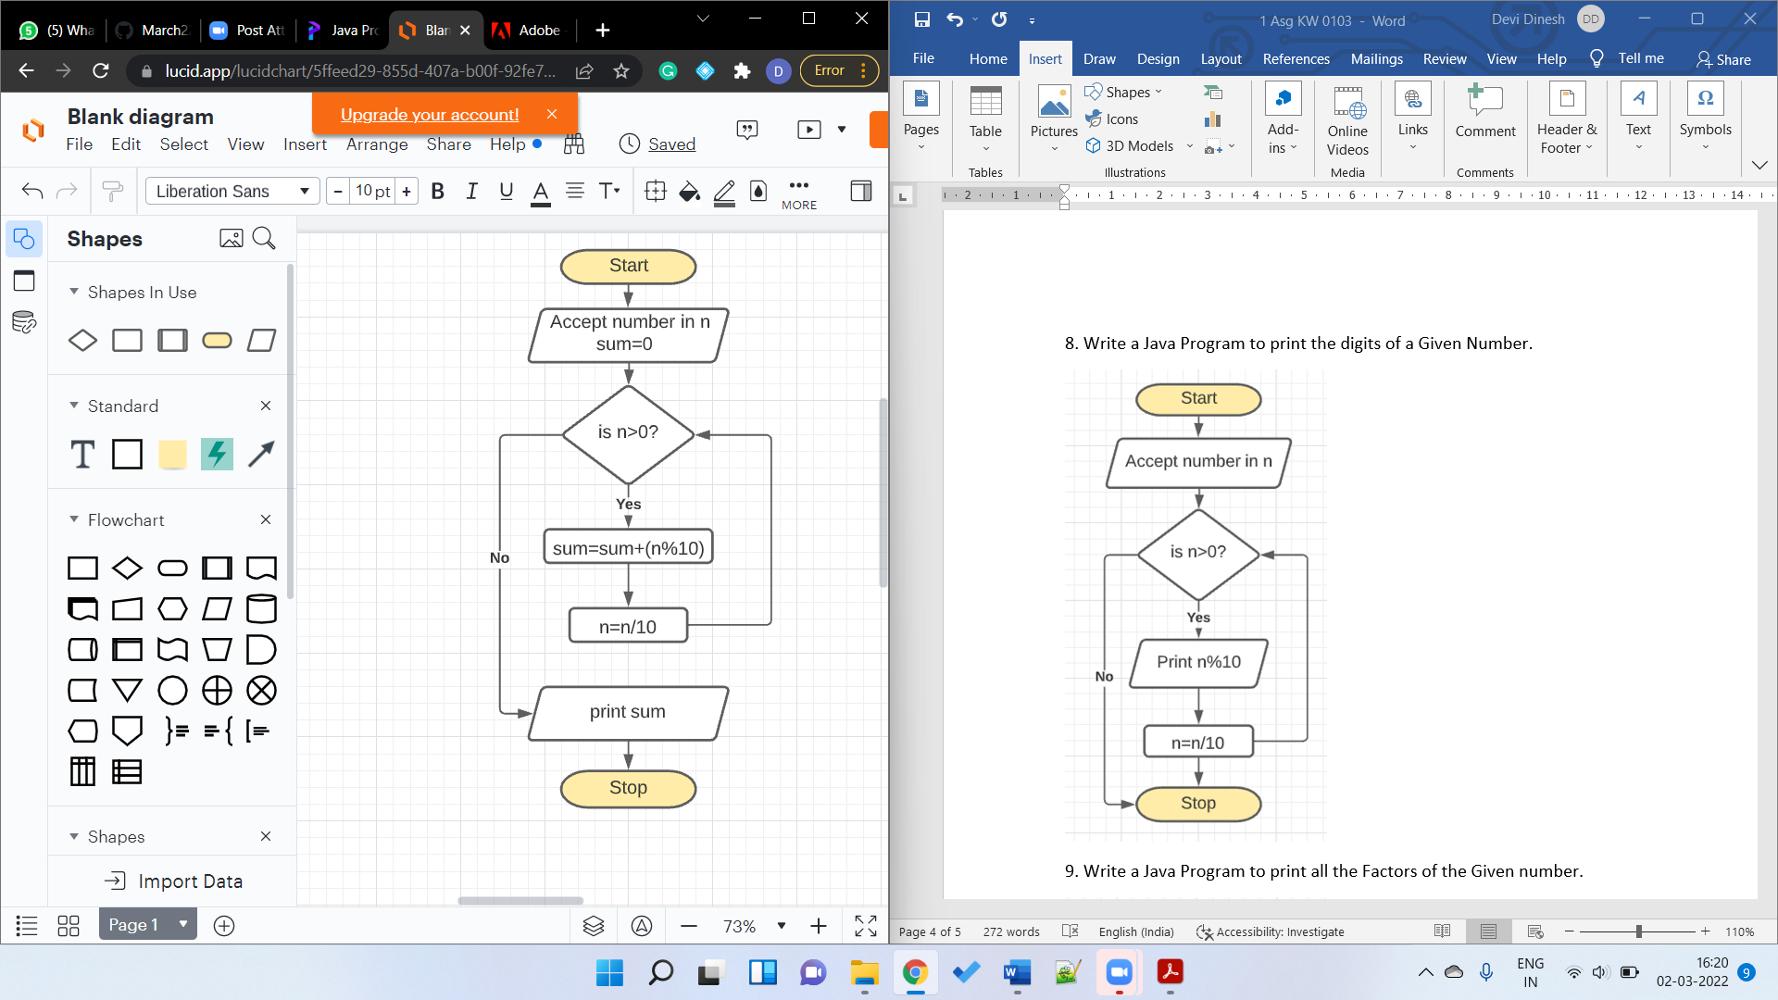

11. Write a Java Program to find the smallest of 3 numbers (a,b,c)

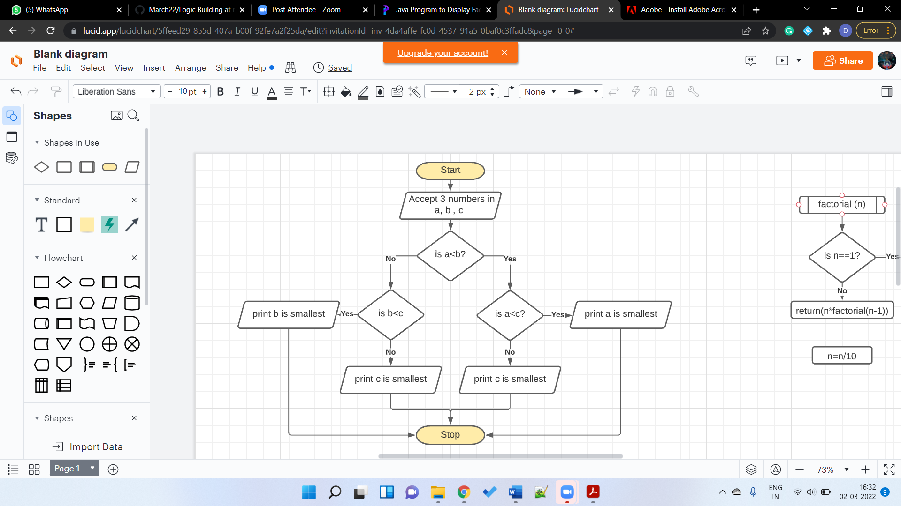

12. How to add two numbers without using the arithmetic operators in Java?

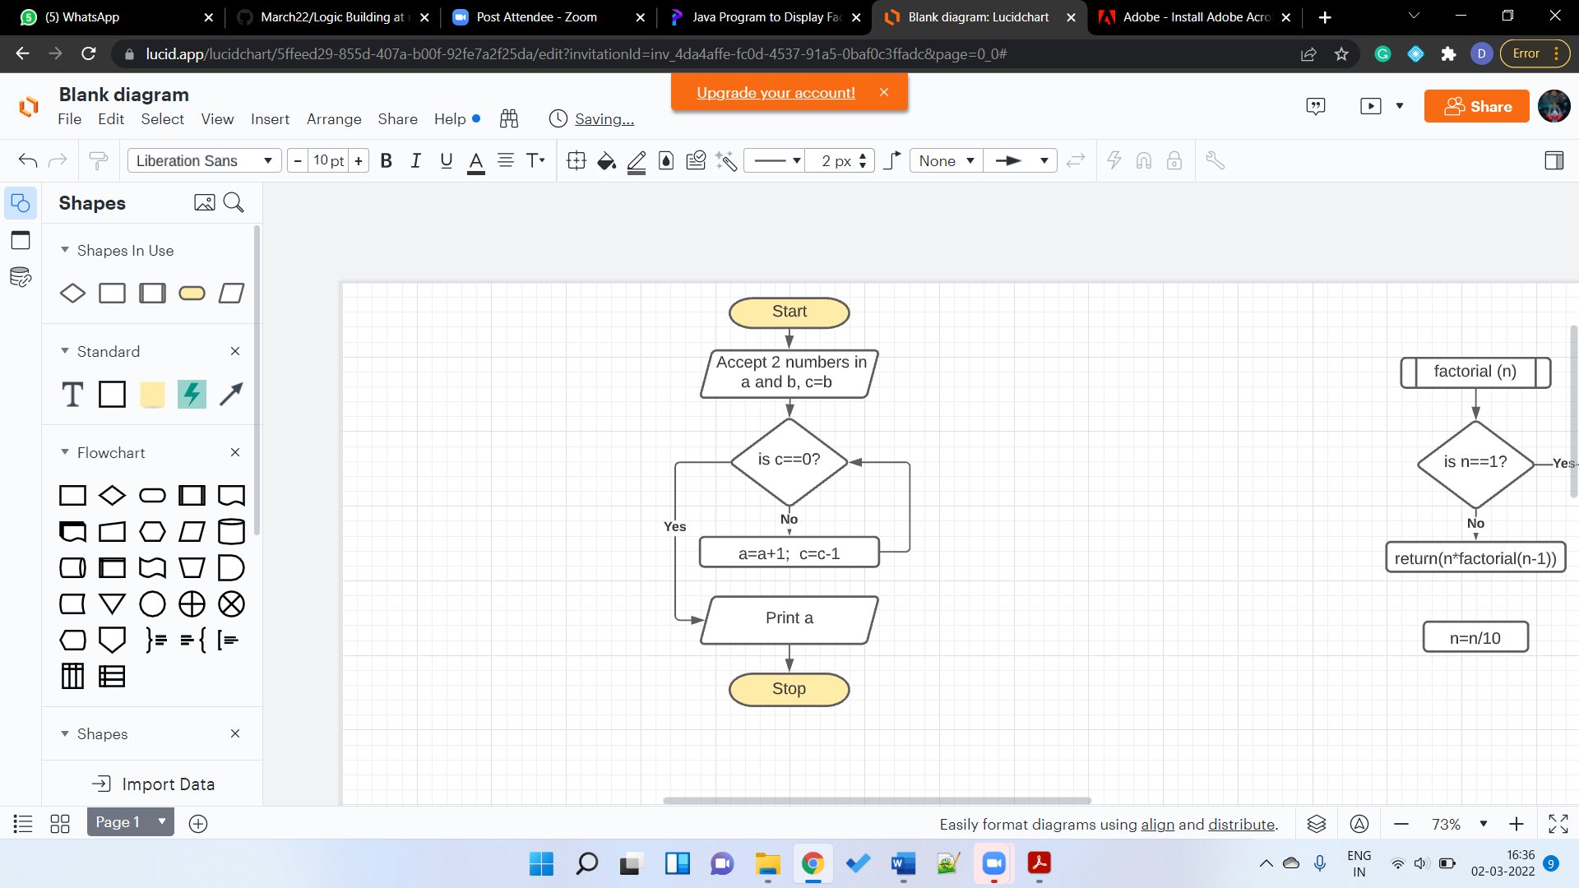

13. Write a java program to Reverse a given number.

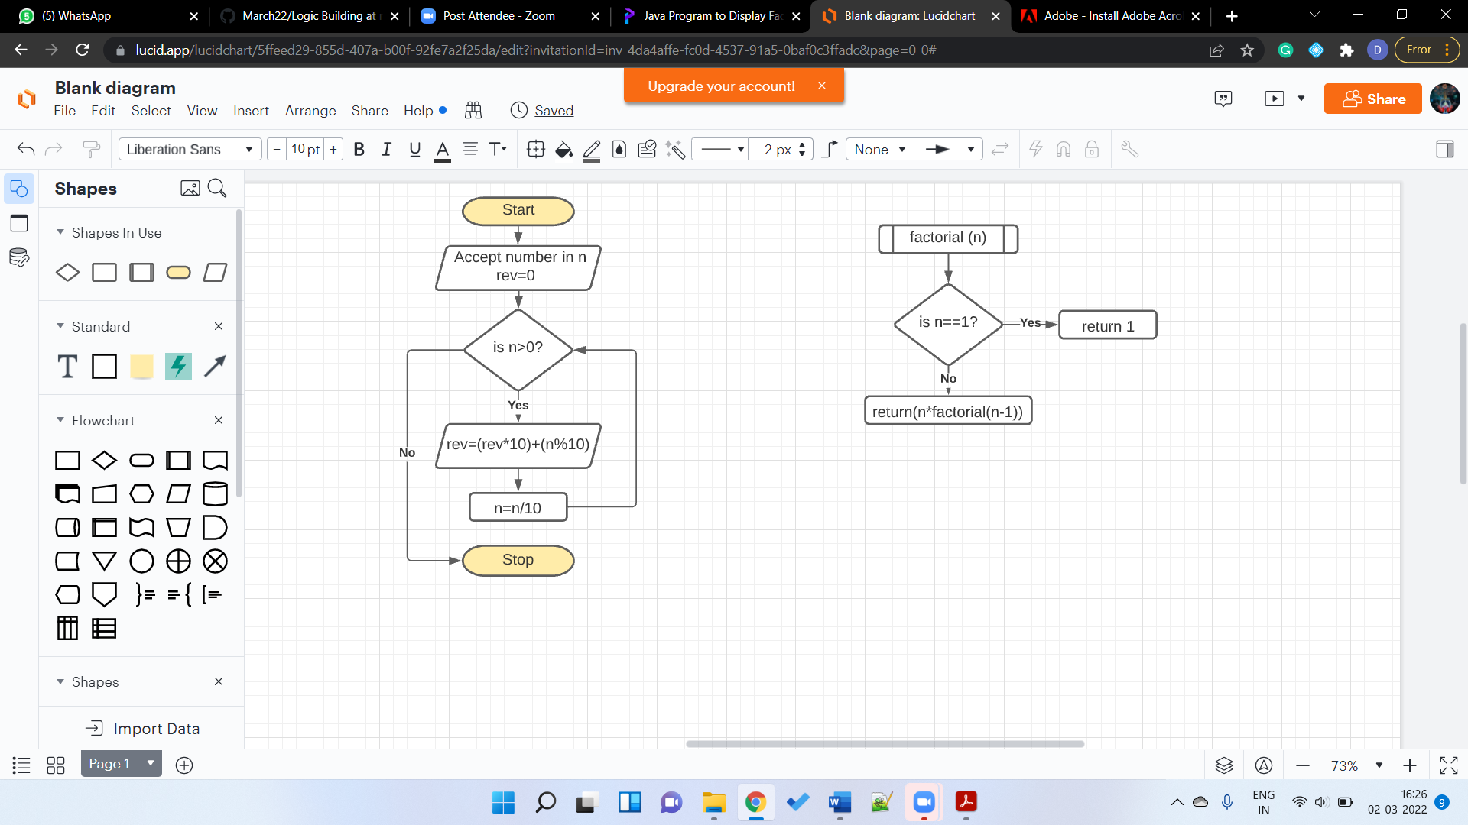

14. Write a Java Program to find GCD of two given numbers.

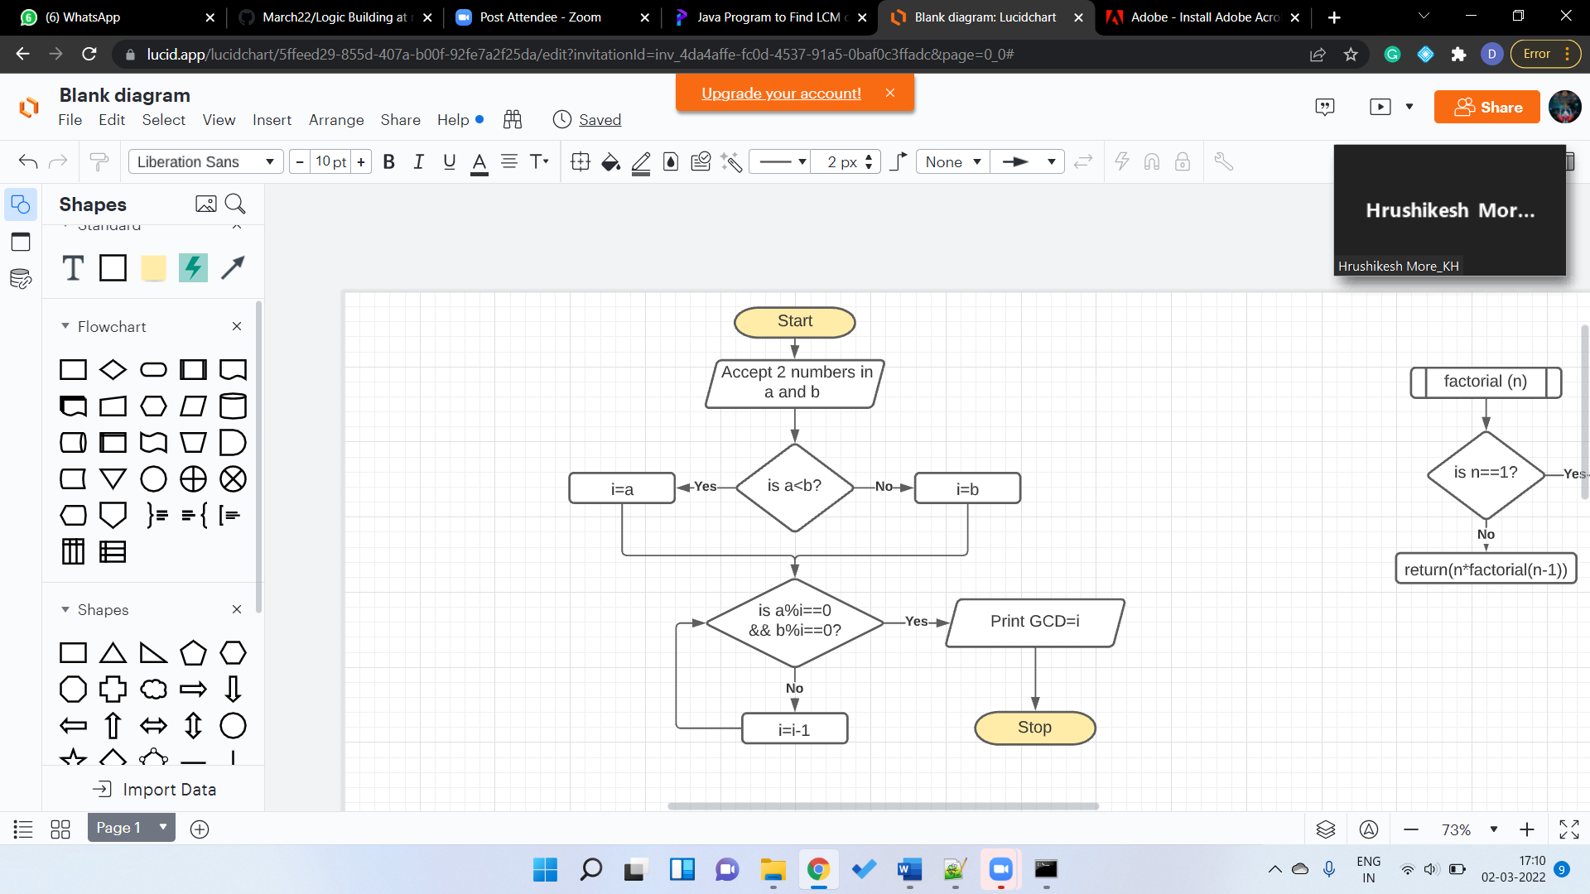

15. Write a java program to LCM of TWO given number.

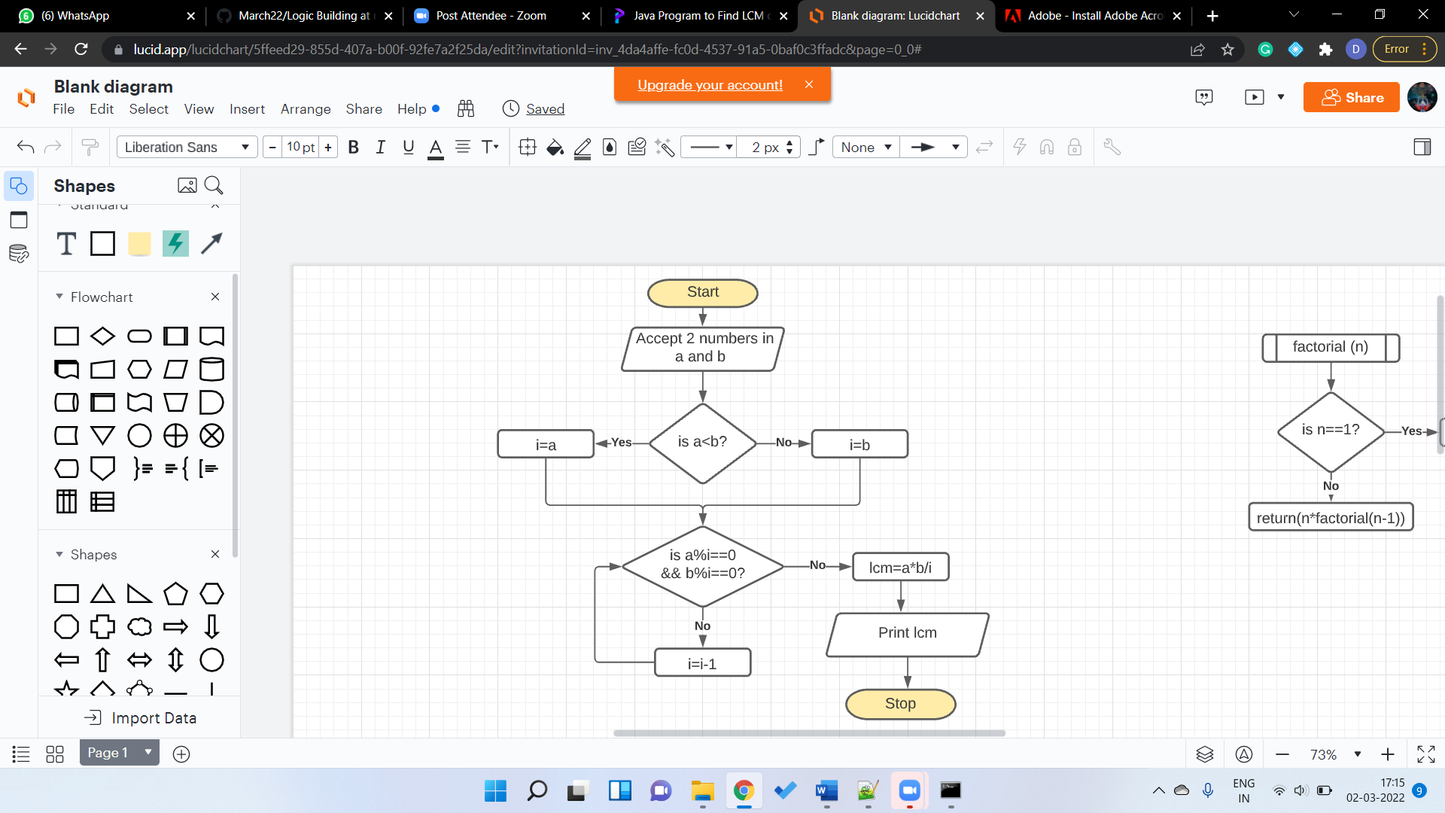

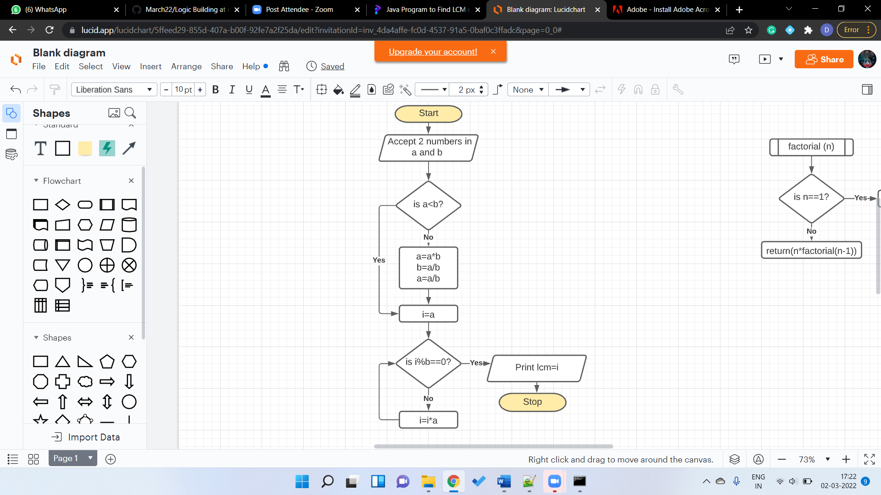

16. Write a java program to LCM of TWO given number using Prime Factors method.

17. Check whether the Given Number is a Palindrome or NOT.

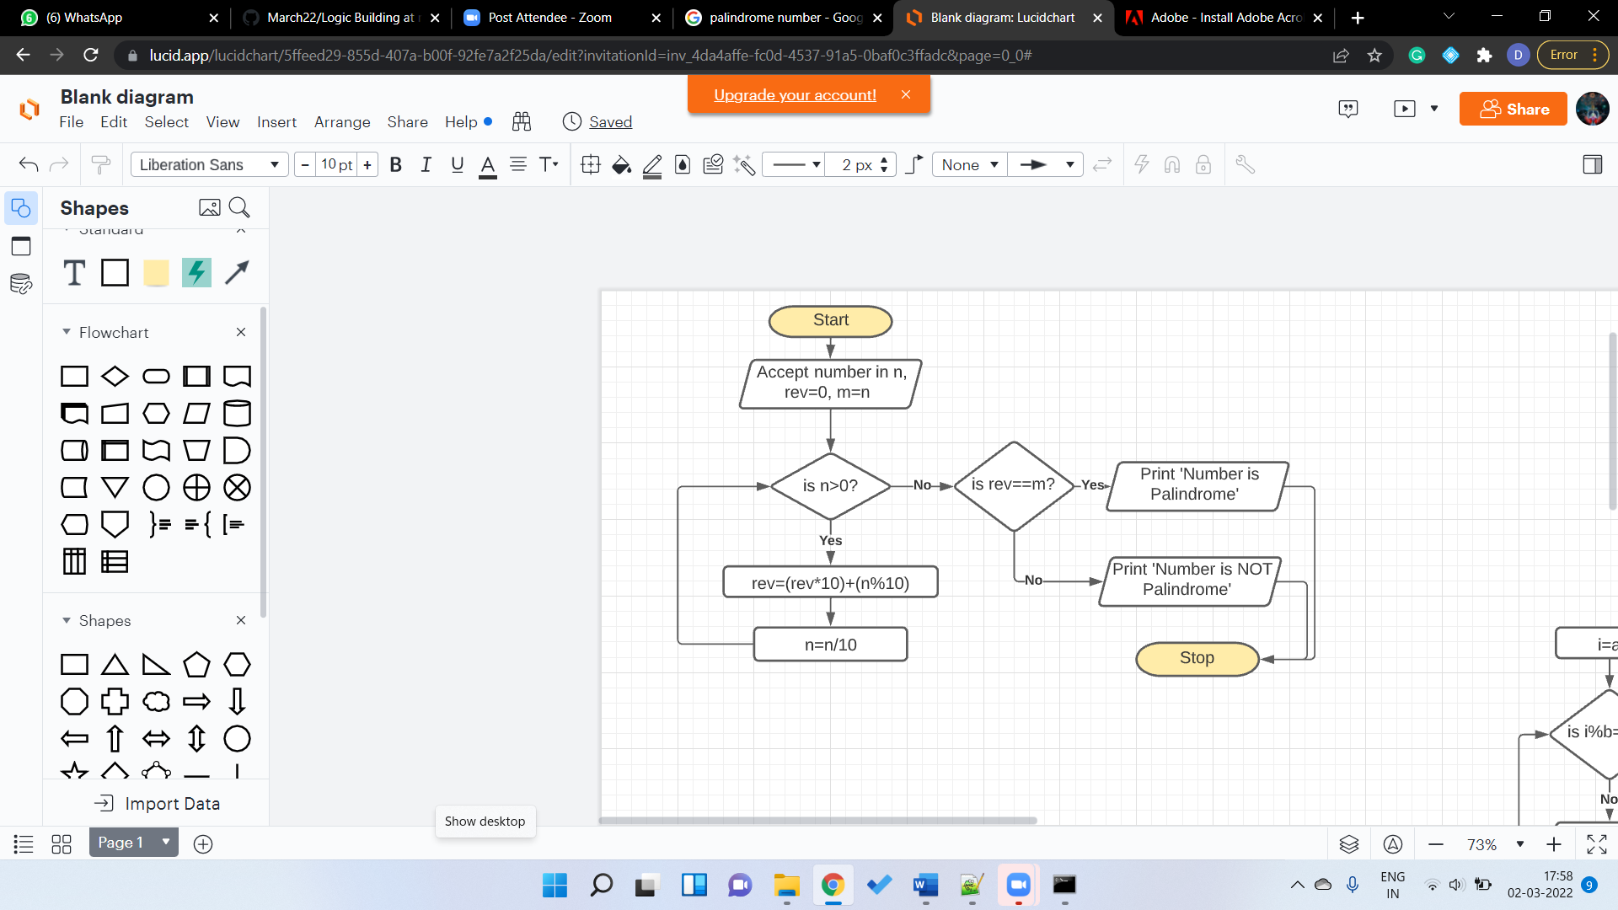

18. Write a Java Program to print all the Prime Factors of the Given Number.

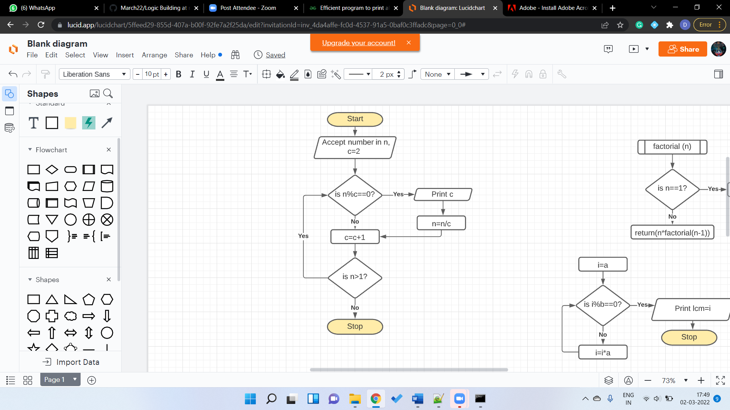

19. To print the following series EVEN number Series 2 4 6 8 10 12 14 16 .....

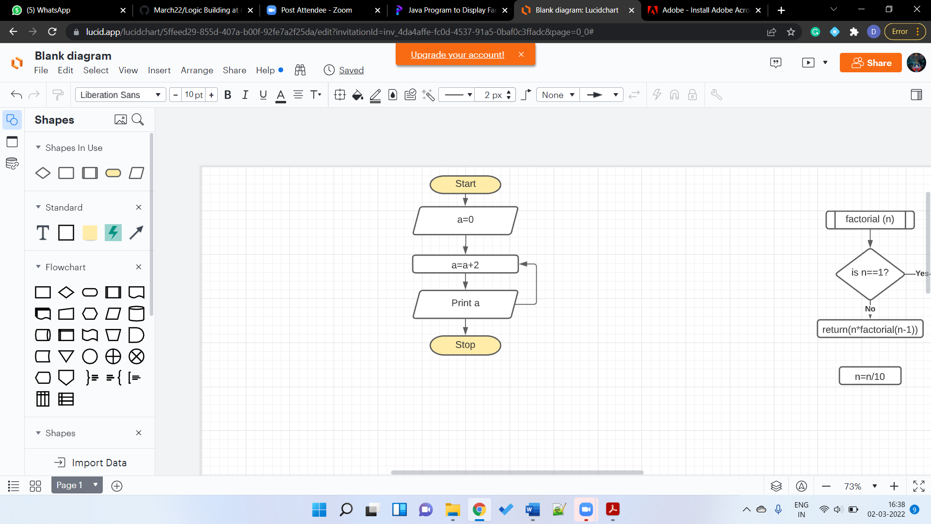

20. To print the following series ODD number Series 1 3 5 7 9 11 13 ....

